Packet Tracer - Configure Basic Wireless Security

1. Topology

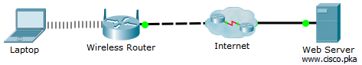

1. Objectives

Configure basic wireless security using WPA2 Personal.

1. Background / Scenario

A small business owner learns that the wireless network should be secured from unauthorized access. He has decided to use WPA2 Personal for his network.

* + 1. Verify connectivity.
       1. Access the **Desktop > Web Browser** on the laptop.
       2. Enter **www.cisco.pka** into the URL. The web page should display.
    2. Configure basic wireless security.
       1. Enter **192.168.1.1** in the web browser to access the wireless router. Enter **admin** as the username and password.
       2. Click **Wireless** menu. Select **Wireless Security** menu.
       3. The security mode is disabled currently. Change the security mode to **WPA2 Personal**.
       4. In the Passphrase field, enter **Network123**.
       5. Scroll down to the bottom of the page and click **Save Settings**. Close the web browser.
    3. Update the wireless settings on Laptop.
       1. Click **PC Wireless** in the Desktop tab.
       2. Click **Connect** tab. Select the **Academy** and click **Connect**.
       3. Enter **Network123** as the pre-shared key. Click **Connect**.
       4. Close the **PC Wireless** window.
    4. Verify connectivity.
       1. Access the **Web Browser**.
       2. Enter **www.cisco.pka** into the URL. Verify that the web page displays after the addition of basic wireless configuration.
       3. If you are unable to access the web page, verify your wireless settings on the wireless router and the laptop. Also verify that laptop is connected to the wireless router.